UNITED UNIVERSITY
Faculty of Commerce & Management
BBA (IBM)

PRACTICAL PROJECT REPORT
PREDICTIVE ANALYTICS
CUSTOMER CHURN PREDICTION
USING MICROSOFT POWER BI
A practical study of customer data preparation, churn indicators and dashboard design

Particulars | Details
Student Name | Harjas Singh
Roll Number | 24051020016
Course / Programme | BBA (IBM)
Subject | Predictive Analytics
Software Used | Microsoft Power BI Desktop
Academic Session | 2026–27

Submitted to: ______________________________
Note: This report is a practical project template based on the supplied reference report and dashboard image. The provided telecom test file contains five records without a Churn target; therefore, no actual churn predictions or model-accuracy figures are claimed.

CONTENTS
S. No. | Section | Page
— | Abstract | 3
1 | Introduction | 3
2 | Problem Statement and Objectives | 4
3 | Software and Tools Used | 4
4 | Dataset Description and Preparation | 5
5 | Practical Procedure in Power BI | 6
6 | Dashboard Design and Reference Image Analysis | 7
7 | Churn Analysis Measures and Interpretation | 8
8 | Results, Limitations and Future Scope | 9
9 | Conclusion and Learning Outcomes | 10
— | References | 10

ABSTRACT
Customer churn occurs when a customer stops using a company’s product or service. Churn prediction uses customer history and service-related information to estimate which customers may be at risk of leaving. This project explains how Microsoft Power BI can be used to import, clean, model and visualise customer data for churn analysis.
The reference practical report provides a five-row telecom test dataset with nine fields, including tenure, contract type, internet service, technical support and billing amounts. It has no Churn/target column. Accordingly, this report focuses on preparing the data and designing a Power BI dashboard framework. Actual prediction labels, probabilities and model accuracy are not reported because a labelled training dataset and a trained predictive model were not supplied.

1. INTRODUCTION

1.1 Background
Businesses seek to retain existing customers because customer loss can reduce recurring revenue and increase the cost of acquiring replacements. In telecommunications, churn may be associated with contract flexibility, service quality, customer support, price, tenure or changing needs. These factors are possible indicators, not proof of the reason a specific customer leaves.

1.2 Predictive Analytics and Power BI
Predictive analytics applies patterns from historical data to estimate future outcomes. Power BI is primarily a business intelligence and visualisation platform. It supports data preparation through Power Query, relationships and measures through its data model and DAX, and interactive reporting through visuals and slicers. A genuine churn prediction model must be trained using labelled historical data in a suitable modelling tool or service; Power BI can then present scored results.

1.3 Purpose of the Practical
The purpose is to demonstrate a responsible Power BI workflow for a customer churn project: importing the supplied file, checking field types, creating clear measures, designing interactive visuals and documenting the requirements for adding model-generated churn scores.

2. PROBLEM STATEMENT
A telecom business wants to identify customers who may discontinue service so that its retention team can prioritise follow-up. The available test data contains customer, contract, service and billing details, but the actual churn outcome is missing.
Element | Description
Input data | Five sample customer records and nine fields.
Key limitation | No Churn field such as Yes/No or Active/Churned.
Practical task | Prepare and explore the data in Power BI and define a dashboard layout for churn analysis.
Business use | When valid model scores become available, use the report to identify groups that may need retention attention.

3. OBJECTIVES OF THE PROJECT
- To understand customer churn and its business importance.
- To import the customer dataset into Power BI Desktop and inspect its structure.
- To identify appropriate data types and check the quality of the available fields.
- To create basic descriptive measures and visuals for customer profiles and billing information.
- To design an interactive dashboard inspired by the supplied Power BI screenshot.
- To distinguish descriptive analysis from genuine predictive modelling.
- To document the data and validation required before churn predictions can be used for business decisions.

4. SOFTWARE AND TOOLS USED
Tool / Feature | Purpose
Power BI Desktop | Main environment for data modelling, report creation and interactive visuals.
Power Query Editor | Import, clean, rename and transform columns; check nulls and data types.
Data / Model view | Inspect columns, set types and manage relationships where needed.
DAX measures | Calculate descriptive totals, averages and—once labels exist—churn KPIs.
Slicers and visuals | Filter the report by contract, service or customer group and communicate patterns.
CSV file | Portable source format for the sample customer records.

5. DATASET DESCRIPTION AND PREPARATION

5.1 Dataset Overview
The supplied reference report describes a file named customer_churn_test_5_rows_without_target.csv. It contains five records and nine fields. The following values are reproduced from that reference document; they are example records for demonstrating the workflow, not a representative sample of the entire telecom market.
CustomerID | Gender | SeniorCitizen | TenureMonth | Contract | InternetService | TechSupport | MonthlyCharges | TotalCharges
101 | Male | 0 | 5 | Month-to-month | Fiber optic | No | 89.99 | 449.95
102 | Female | 0 | 36 | One year | DSL | Yes | 54.50 | 1962
103 | Male | 1 | 60 | Two year | Fiber optic | Yes | 79.20 | 4752
104 | Female | 1 | 2 | Month-to-month | DSL | No | 68.75 | 137.50
105 | Male | 0 | 18 | One year | No | No | 25.00 | 450

5.2 Field Definitions and Suggested Data Types
Field | Meaning | Power BI type / handling
CustomerID | Unique customer reference | Text or whole number; do not treat as a churn driver.
Gender | Recorded gender category | Text; use only where appropriate and permitted.
SeniorCitizen | 0/1 indicator | Whole number or categorical flag.
TenureMonth | Months with the service | Whole number.
Contract | Contract length category | Text.
InternetService | Type of internet service | Text.
TechSupport | Support availability/status | Text.
MonthlyCharges | Monthly bill amount | Decimal number / currency.
TotalCharges | Accumulated charges | Decimal number / currency.

5.3 Data Quality Checks
- Confirm that the first row is used as column headers and that all nine fields are loaded.
- Check for blank values, inconsistent category spelling, unexpected symbols and duplicate customer IDs.
- Convert MonthlyCharges and TotalCharges to decimal numbers; confirm that currency values are not imported as text.
- Keep CustomerID as an identifier rather than a numeric predictor.
- Do not create or guess a Churn column. The supplied file has no known churn outcome.

6. PRACTICAL PROCEDURE IN POWER BI

Step 1 — Open Power BI Desktop
Create a new report and save it with a clear name, for example Customer_Churn_Prediction_Harjas_Singh.pbix.

Step 2 — Import the file
Choose Home → Get data → Text/CSV, select the supplied customer file and preview the columns before loading.

Step 3 — Transform the data
Select Transform Data to open Power Query Editor. Promote headers if required, rename fields only when useful, set data types and inspect blank or invalid values.

Step 4 — Apply changes
Select Close & Apply. Confirm the five records and nine columns appear in the Data view.

Step 5 — Create descriptive measures
Use DAX measures for record count, average tenure and total monthly charges. These measures describe the sample only; they do not predict churn.

Step 6 — Build visuals
Add cards, bar charts, a table and slicers for contract, internet service and technical support. Use readable titles and consistent number formatting.

Step 7 — Add model scores only when available
If a separately trained and validated model generates Churn Prediction and Churn Probability fields, import the scored output and connect it to the customer data using a suitable customer key.

Step 8 — Validate and publish
Check totals against the source data, test slicers, label all metrics clearly and publish only if permitted by the organisation’s data policies.

6.1 Example Descriptive DAX Measures
The following measures are examples for a Power BI table named Customers. Adjust the table and field names to match the imported file.
Customer Count = DISTINCTCOUNT(Customers[CustomerID])
Average Tenure (Months) = AVERAGE(Customers[TenureMonth])
Total Monthly Charges = SUM(Customers[MonthlyCharges])
Average Monthly Charges = AVERAGE(Customers[MonthlyCharges])
These measures are descriptive. A churn rate measure cannot be calculated from this file because there is no actual Churn field.

7. DASHBOARD DESIGN AND REFERENCE IMAGE ANALYSIS
The supplied screenshot is a Power BI dashboard titled “CATEGORY AND SUB - CATEGORY LEVEL ANALYSIS.” It is a sales/profit dashboard, not a churn dashboard. It is used here as a visual-layout reference only. Its sales figures and category findings must not be interpreted as telecom churn results.
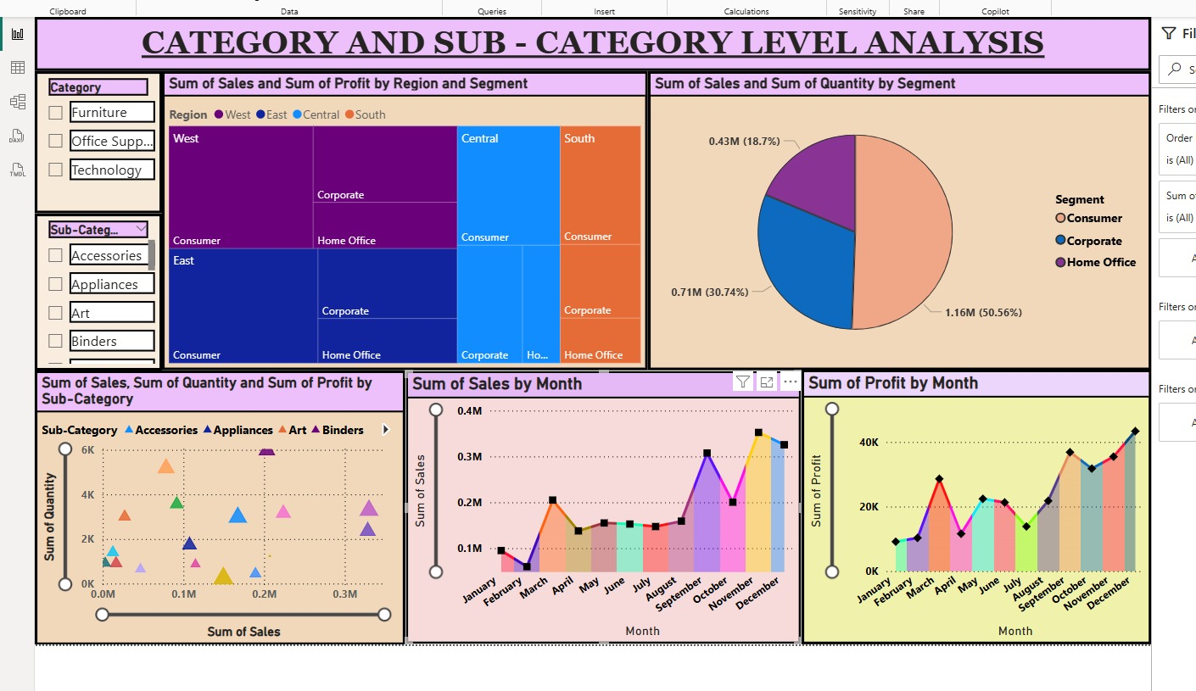
Figure 1. Supplied Power BI dashboard screenshot used as a layout reference (sales and profit analysis).

7.1 What the Reference Dashboard Shows
Reference visual | Purpose in the screenshot | Possible churn-project equivalent
Category and sub-category slicers | Filter sales analysis by product groups. | Contract type, InternetService and TechSupport slicers.
Treemap by region and segment | Compare contribution across hierarchical groups. | Customer count or churned customers by contract and service group—only when actual churn labels exist.
Pie chart by segment | Show quantity share across segments. | Customer distribution by contract type; avoid implying churn share without target data.
Scatter chart by sub-category | Compare sales, quantity and profit dimensions. | Explore tenure versus monthly charges; use churn colour only after real labels are available.
Monthly sales and profit charts | Show monthly business trends. | Monthly churn rate or churn count, if dated labelled data is available.

7.2 Recommended Churn Dashboard Layout
A practical Power BI page can place KPI cards across the top, slicers along the left, customer-segment visuals in the centre, and trend or detail charts along the bottom. Use a restrained colour palette, legible labels and consistent units. Red or orange may highlight verified high-risk groups, while neutral colours should be used for general categories.

7.3 Proposed Dashboard Components
Visual / Component | Fields or metric | Question answered
KPI card: Total customers | Distinct count of CustomerID | How many customers are in the selected view?
KPI card: Actual churn rate | Churned customers ÷ customers with known outcome | What proportion actually churned? Requires labelled data.
Bar chart: Churn by contract | Contract and churn count/rate | Which contract groups show higher observed churn? Requires labels.
Column chart: Churn by tenure band | Tenure band and churn rate | Does churn vary across tenure groups? Requires labels.
Stacked bar: Service/support | InternetService, TechSupport and churn status | How do service groups compare? Requires labels.
Scatter plot: Charges vs tenure | MonthlyCharges, TenureMonth | How are billing and tenure distributed? Descriptive only unless coloured by real churn status.
Detail table | CustomerID, contract, tenure, charges, model score | Which records need review after validated scores are added?

7.4 Interactivity
- Add slicers for Contract, InternetService, TechSupport and tenure bands.
- Use Edit interactions so selecting a category filters relevant visuals without hiding important context.
- Add tooltips with definitions and date ranges so viewers understand the metric being shown.
- Keep actual churn status, predicted churn and probability as separate fields.

8. CHURN ANALYSIS MEASURES AND INTERPRETATION

8.1 Key Metrics
Metric | Definition | Data requirement
Customer count | Distinct customers in the selected filter context | CustomerID
Actual churn rate | Customers with actual churn status = Yes ÷ customers with known status | Labelled Churn field
Predicted churn count | Records classified as likely to churn by a trained model | Model-scored output
Average tenure | Average number of months customers have stayed | TenureMonth
Average monthly charges | Mean monthly charge across selected customers | MonthlyCharges
Model precision / recall | Measures of prediction quality against known outcomes | Predictions plus actual labels

8.2 Example Interpretation of the Available Sample
Within the five records, tenure ranges from 2 to 60 months and monthly charges range from 25.00 to 89.99. Contract types include month-to-month, one-year and two-year arrangements. InternetService includes Fiber optic, DSL and No. Technical support is recorded as both Yes and No.
These differences can be explored in Power BI as descriptive patterns. They do not prove that any customer is likely to churn. Without known churn outcomes, no actual churn rate, customer risk label, model confidence score or prediction accuracy can be calculated.

9. RESULTS, LIMITATIONS AND FUTURE SCOPE

9.1 Practical Results
Area | Result supported by the supplied materials
Data structure | Five customer records and nine fields are described in the reference report.
Customer profile | The sample includes varied tenure, contract, service and support values.
Billing profile | MonthlyCharges ranges from 25.00 to 89.99 in the five supplied records.
Dashboard design | The supplied screenshot provides a layout reference for slicers, grouped comparisons, scatter analysis and trend visuals.
Prediction outcome | Not available: the test data has no target and no scored model output was supplied.
Accuracy evaluation | Not available: evaluation requires predicted outcomes and actual known churn labels.

9.2 Limitations
- The sample contains only five records and cannot represent a full telecom customer population.
- The dataset does not contain an actual Churn target field.
- No labelled training dataset, trained model or model-scoring output was provided.
- Power BI visuals alone do not establish a predictive model; valid model scores must be generated by a trained model or supported integration.
- No accuracy, precision, recall, F1-score or confusion matrix can be reported from the supplied unlabelled file.

9.3 Future Scope
- Obtain a larger, recent dataset with verified churn outcomes and an appropriate train/validation/test split.
- Investigate missing values, duplicates, category consistency and possible data leakage.
- Train and compare suitable classification models using a modelling environment, then validate the selected model.
- Import scored records into Power BI and show prediction date, model version and probability definitions.
- Add relevant data such as complaints, payment behaviour and service incidents where lawfully available.
- Monitor model performance and fairness over time; do not use a score as the sole basis for adverse customer decisions.

9.4 Responsible Use
Customer information should be handled according to applicable privacy rules and company policy. Limit access to identifiable data, use aggregated visuals where possible, and explain that a predicted risk is an estimate—not a certainty or a reason to treat an individual unfairly.

10. CONCLUSION
This practical project explains how Microsoft Power BI can support a customer churn analysis workflow through data preparation, descriptive measures, interactive visuals and dashboard design. The supplied Power BI screenshot is useful as a design reference because it demonstrates slicers, grouped comparisons, a scatter plot and monthly trend charts. Its sales and profit values are unrelated to customer churn and have not been reused as churn findings.
The referenced telecom test file contains five customer records with profile, contract, service and billing fields but no actual churn outcome. It can support data preparation and descriptive exploration; it cannot independently train or evaluate a supervised churn model. Genuine churn predictions should be added only after a model has been trained and validated on labelled historical data. This distinction keeps the report transparent and prevents invented results.

10.1 Learning Outcomes
- Understood customer churn and why customer retention matters.
- Learned the role of Power Query, data types, DAX measures and report visuals in Power BI.
- Identified the difference between descriptive analysis and predictive modelling.
- Learned how slicers, cards, charts and detail tables can support an interactive dashboard.
- Recognised the need for labelled outcomes and model validation before reporting churn predictions.

REFERENCES
- Supplied reference practical report: Customer Churn Prediction Using IBM SPSS Modeler (2026–27). Used for the dataset description, sample records and modelling limitations.
- Supplied Power BI dashboard screenshot: “CATEGORY AND SUB - CATEGORY LEVEL ANALYSIS.” Used as a layout and visualisation reference only.
- Microsoft Learn, Power BI documentation: Get data, Power Query, data modelling, DAX and report visualisation. https://learn.microsoft.com/power-bi/
- Predictive Analytics course material and practical instructions.
— End of Report —

